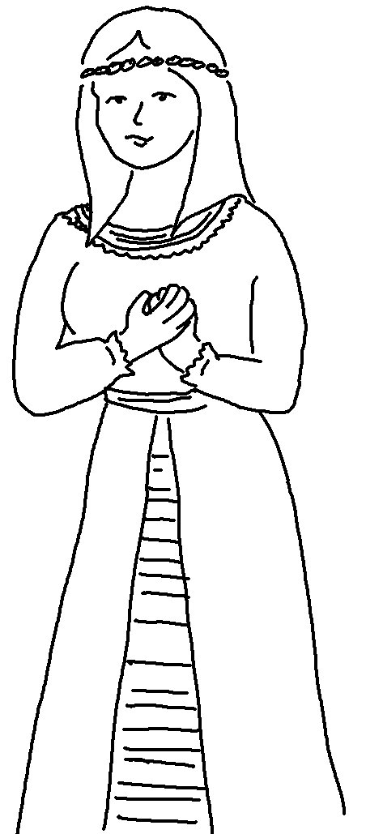

Who knows if perhaps you were made queen for just such a _ _ _ _ as this? Esther 4:14

